**Dried Blood Spot (DBS) Collection and Handling**

**PURPOSE**

This SOP outlines the procedure to be followed when Dried Blood Spot (DBS) samples from a finger prick DBS are collected for viral load testing for HIV RNA. It also outlines the procedures to follow in case of a needle stick injury.

**PRINCIPLE**

A finger prick is done when collecting blood for Dried Blood Spots (DBS). DBS requires a lesser volume of blood with reduced infectious risk making it safer to handle than whole blood. It can also be stored and transported at room temperature (15-30 degrees).

**RESPONSIBILITIES**

All field staff are responsible for understanding and following this SOP.

**STAFF TRAINING REQUIREMENTS**

All staff that collect DBS specimens must have completed formal training before collecting DBS cards and have successfully completed a competence sheet.

**MATERIALS AND EQUIPMENT**

1. Lasec DBS Card
2. Gas impermeable storage bags
3. Desiccant packs
4. Humidity indicator (cards)
5. Alcohol swabs
6. Bandage/Plaster
7. Lancet
8. Drying racks
9. DBS lab requisition form
10. Gloves (always wash off the powder to avoid contaminating the specimens)
11. DBS transport and storage box

**PROCEDURES**

**1. Labeling the DBS card**

The DBS is collected on a Lasec DBS card. Prior to the specimen collection, the DBS cards and lab requisition forms are labeled with the patient’s information.

For this study, we will use the patient ART number. Label the DBS card with the following:

1. Patient ART ID number
2. Site identification number
3. DBS preparation date/time

**2. Collecting specimen for DBS**

1. First, wash your hands before putting on gloves. If you wear powdered gloves, wash and dry your gloved hands to remove as much powder as possible.
2. Handle the DBS card carefully using the edges; NEVER touch the areas where the blood will be collected.
3. Use whole blood sample from finger prick.
4. Make sure to warm the participant’s hand and make sure the hand is below the level of the elbow (to allow gravity to help you collect the blood).

**NOTE:** When you do the finger prick sometimes blood comes out very slowly especially if it is cold or the person has thick skin. A lot of the time the instinct is to squeeze the finger WHICH IS WRONG, but a better way to do it is to make sure that the finger is pointing down (below the palm) and to squeeze the palm broadly instead.

1. Select finger for the procedure. Clean patient finger with disinfectant or alcohol wipe, generally middle or ring finger is preferred, avoid fingers with rings on.
2. Allow to air dry for 30 seconds.
3. Use a sterile, disposable lancet to puncture the skin to the side of the fingertip.
4. Dispose of the lancet in the biohazard container.
5. With the finger extended, wipe away the first drop of blood then allow a large, hanging drop of free-flowing blood to accumulate at the puncture site.
6. To collect the drop of blood, touch the filter paper to the edge of the drop, allowing the blood to be drawn into the first circle on the card by capillary action. DO NOT allow the finger to touch the card.
7. Then, allow another large drop of free-flowing blood to form at the puncture site and collect this drop in the **NEXT** circle.
8. You need only **ONE LARGE DROP PER CIRCLE.** Do not layer multiple drops of blood on top of each other.
9. Continue collecting drops of blood in the same manner until all the circles are filled on the DBS card (Fig 1. and 2.).

**Fig 1. Valid DBS cards**

All DBS must be collected on Lasec paper

Identifying information on the DBS card must match information on the lab requisition form

At least 3 spots 6mm in diameter or larger must be obtained

After drying, DBS should be dark and uniformly coloured



NAME*: JP 5040-133-0000-1*

DATE: *14/11/2014*

DOB: *01/10/2014*

Facility: *Kalingalinga - ALERE*

District: *Lusaka*

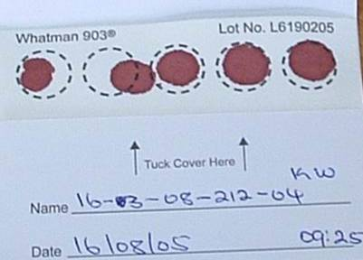

All 5 circles filled. At least 3 are valid.

**Fig2. Invalid DBS card**

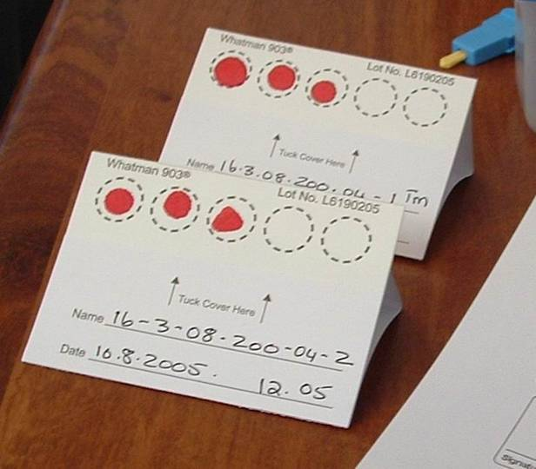

Blood spots are too small

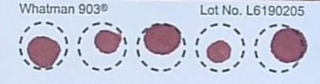

**4** Circles not filled

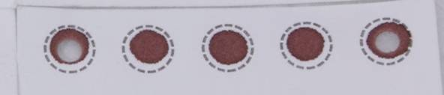

4.2**.** Blood has clotted

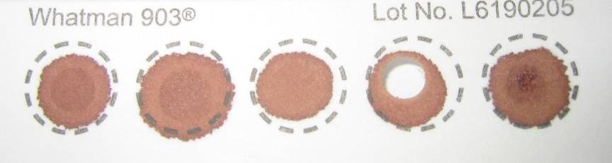

Specimen has clotted and appears layered

1. If the blood stops flowing before sufficient blood has been collected, gently massage the hand to encourage blood droplets formation. **DO NOT MILK THE FINGER** (i.e. do not squeeze or massage the finger area).

If necessary, a second finger can be cleaned and punctured using a new lancet in order to obtain adequate sample. It is important that adequate sample is collected; you must saturate each circle with blood.

1. If you are unable to obtain flowing blood using finger stick despite multiple attempts, please inform a head nurse or clinician.
2. After adequate sample is collected, give the participant gauze or swab to hold pressure to the fingertip. Elevate the fingertip above the elbow. After a matter of seconds or minutes, the bleeding should stop. No strapping, plaster, or band-aid is needed.

**3a. Handling specimen after collection in the CLINIC**

This section describes the procedure for handling a collected DBS specimen in the clinic.

1. After completing the sample collection, place the DBS card on the drying rack (Fig 3). The drying rack should ideally be placed so that the DBS cards dry in the horizontal position.
2. If no drying rack is available, the DBS card can be laid flat on a clean paper towel.
3. Fill out the lab requisition form and leave it close to the DBS card, so it can accompany the card to the lab, once dry.

**Fig 3. DBS on drying rack**

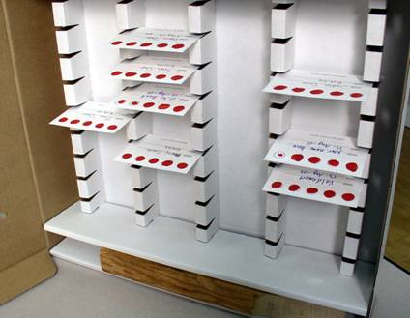

PRECAUTIONS WHEN DRYING THE DBS CARDS:

* Do not touch or smear the blood spots
* Keep away from direct sun-light, dust, and insects
* Do not heat, stack or allow DBS to touch anything during the drying process (including other DBS cards)

1. DBS cards must dry for at least 4 hours (though preferably overnight) prior to being placed in plastic bags and transported to the lab. **DO NOT USE AN EXTERNAL HEAT SOURCE TO DRY DBS.**
2. When dry, the spots will appear a uniform dark brown. The appearance should be similar to that of a dried bloodstain and no areas of red coloration should be seen.

**3b. Handling specimen after collection in the FIELD (outside of clinic) using a transport box**

This section describes the procedure for handling a collected DBS specimen in the field (outside of clinic).

1. Follow the procedure above for collecting DBS (2.1-2.16).

1. Allow the DBS card to dry sufficiently so blood is not flowing when placed in a transport box
2. Appropriately place the DBS card horizontally in a rack already provided in the transport box
3. The transport box must be carried horizontally at all times. **PROTECT YOUR DBS CARD FROM ANY DUST OR DIRECT SUNLIGHT AT ALL TIMES.**

1. When you return to the facility at the end of your tracing activities, ensure that each DBS card has had a lab requisition form filled out
2. When you arrive at the facility, remove the DBS card and leave to air dry effectively for 4 hours or till the next morning. If no drying rack is available at the facility, the DBS card can be laid flat on a clean paper towel.

1. Fill out the lab requisition form and leave it close to the DBS card, so it can accompany the card to the lab, once dry. Ensure the first two copies of the lab requisition accompany the DBS card to the lab. Retain the third copy for facility records.

**4. Packaging of DBS**

Packaging of the DBS is very important. DBS cannot be kept and/or transported at ambient temperature for longer than 14 days. If VL testing cannot be performed within 14 days from the date of collection, DBS should be transported to a central facility where there is a constant electricity supply and a -70°C freeze.

The manner in which the DBS are packaged may determine the quality of the results in the future.

1. Once the DBS card is **COMPLETELY DRY**, place the card in a gas-impermeable zip-locked plastic bag with 1 desiccant pack.
2. Humidity causes damage to the HIV virus particles and should be avoided through use of desiccant and humidity cards.
3. The patient information should be visible through the bag. Make sure the humidity card is placed in the rear of the card facing out so that we can read the card and so that it does not obscure the view of the participant information on the card.
4. We want to keep the DBS card sealed in its bag from now to when we are ready to test it. Gently apply pressure to the partially sealed bag to excel the air before sealing completely.
5. Bring the plastic bag containing the DBS along with the lab requisition form to the appropriate area in the clinic so that it can be transported to the reference laboratory. **DO NOT STAPLE THE REQUISITION FORM TO THE PLASTIC BAG** as this will puncture the bag and allow air to enter.
6. Insert DBS bag into envelope. Place lab requisitions and specimen delivery checklist into envelope. Seal envelope. Label envelope clearly (“START DBS specimens”). Send to testing lab.

_______________________________________________________________________

**PROCEDURES FOR NEEDLE STICK INJURY**

Purpose

The purpose of this section is to define procedures to follow when any Community ART staff member suffers a needle stick injury or blood contamination. This procedure applies to all staff involved in collection of blood specimens from Community ART participants.

Responsibilities

The staff members delegated to collect DBS specimens for the studyare responsible for understanding and following this section of the SOP.

The START staff supervisor is responsible for ensuring that START staff knows what action to take when one has a needle stick injury or is exposed to contaminated body fluids when handling and discarding used lancets, broken specimen containers or hazardous waste. In the event of a needle stick injury, the supervisor is responsible for ensuring that the employee receives all necessary medical attention.

Appendices

Standard Operating Procedure: Management of Occupational Exposures to potentially Infectious Substances

**Procedures**

Study staff are to follow the laid down steps in case of needle stick injury and skin exposure while working with a patient with known HIV infection.

1. Immediately wash the site with soap and running water. Antiseptics such as alcohol or chlorohexidine can be used on small wounds and puncture sites – these agents have some virucidal activity. DO NOT USE BLEACH or other caustic agents to clean the exposure site or squeeze the wound.
2. In case of mucosal exposure, the exposed surface should be flushed with numerous amount of saline or water.
3. In case of exposure to the eye, immediately flush with copious amounts of clean water
4. Contact on site or nearby In-Charge/Supervisor. If the In-Charge/Supervisor is not immediately reachable, attempts should be made to reach a head nurse based at the district.
5. The individual with potential HIV exposure should present her/himself nearby health facility for immediate HIV counseling and testing. These results should be made available to health providers during discussions about post-exposure prophylaxis (see below). Should the HIV result be negative, the staff member should follow-up with a repeat test after 3 months.

The individual with potential HIV exposure will be referred to a member of the medical team, who will provide management for post-exposure prophylaxis (see Appendix).

**Dried Blood Spot (DBS) Viral Load Log Book**

**Clinic Name:** _______________________________________________________

|  |  |  |  |  |
| --- | --- | --- | --- | --- |
| **Date of Specimen Collection**  **(DD/MM/YY)** | **Time of Specimen Collection**  **(HH:MM)** | **ART ID** | **Patient First Name** | **Patient Surname** |
|  |  |  |  |  |
|  |  |  |  |  |
|  |  |  |  |  |
|  |  |  |  |  |
|  |  |  |  |  |
|  |  |  |  |  |
|  |  |  |  |  |
|  |  |  |  |  |
|  |  |  |  |  |
|  |  |  |  |  |
|  |  |  |  |  |
|  |  |  |  |  |
|  |  |  |  |  |
|  |  |  |  |  |
|  |  |  |  |  |
|  |  |  |  |  |